Access Modifiers- Control access to variables and methods inside our classes.

Public-

Variables or methods available anywhere

Private-

Variables or methods available only in the class where it was created.

Protected-

Available in the base class and the derived class

Global Variable-

Variable Scope-

Classes, Access Modifiers, constructors, getters, setters, determine variable access in OOP.

**Lab Assignment:**

**Update program Assignment 18**

Create a text file with redacted information.

Use OOP design paradigm, Classes, Inheritance, and Access modifiers.

ofstream input information on 10 students into a text file.

student ID, First Name, Last Name, DOB, and address.

Create a header row for your student information.

Take birthdate information and redact month and day before values are output to text file. Create a Derived/sub class that handles the redaction.

Attach Snipping photo source code and file containing student information. (See attached text file photo below.)

**Old Version**

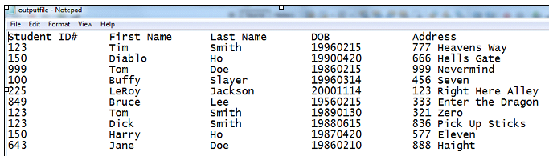

**New Version**

